News Site

Full Stack Project

Henrik Kurkela

Oulu University of Applied Sciences

[henrik.kurkela@gmail.com](mailto:henrik.kurkela@gmail.com)

Table of Contents

1. Preface 2

2. Simple use cases 3

2.1. News story overview 3

2.2. Liking and sharing 3

2.3. Commenting 4

2.4. Signing up and logging in 4

2.5. Account management 4

3. Content moderation 5

3.1. Moderation actions overview 5

3.2. Uploading picture assets 5

3.3. Publishing news items 6

3.4. Comment moderation 7

3.5. News moderation 7

3.6. Advertisements 8

3.7. Reset 8

# Preface

This software project has been developed to satisfy the requirements of Helsinki University course *Full Stack Project*. The software implements a simple news site platform, allowing administrators to publish and edit news stories and readers to leave anonymous or authenticated comments on articles.

The news service works by running an express backend on Heroku. The backend serves a production build of the frontend bound to a wildcard route. This way, all requests that are not handled by an API endpoint are handled by the production front end. News items, comments and user information are stored in a database. Heroku Postgres is utilized since it can be accessed without adding a credit card to Heroku account. Queries are handled using Sequelize, enabling straightforward migrations to other types of SQL databases such as MySQL.

The frontend uses Semantic UI React as a styling framework. Semantic along with Material were recommended by a fellow, though more advanced, programmer. Of these two Semantic UI was chosen mostly by first impressions while skimming through the framework documentation, but also by chance. For http requests, axios was used. Axios was a natural choice since it was used during the *Full Stack Open* course as well. State management was implemented with redux, which was also used during the *Full Stack Open* course.

Building the project was a hugely educational endeavour, which greatly deepened the author’s React skills, especially regarding state management. The biggest takeaway however was the fact that the wheel should not be reinvented. Many a challenge was solved using own solutions, but as the project progressed, these solutions usually turned out to be inadequate. This caused a few incidents of large efficiency losses, as the original coding was completely removed and replaced with a solution utilizing a community-made package. The biggest of these mistakes was to use hand-written MySQL queries with the Node MySQL driver. The queries had a lot of challenging issues, for example with hyphenation in queries. In hindsight starting with an ORM library, such as Sequelize, would have been more than worth the initial time investment to grasp the basics of the library.

# Simple use cases

In this chapter, some simple use cases for normal and anonymous users are covered. These actions are commenting, liking, and sharing news items, as well as personal account management.

## News story overview

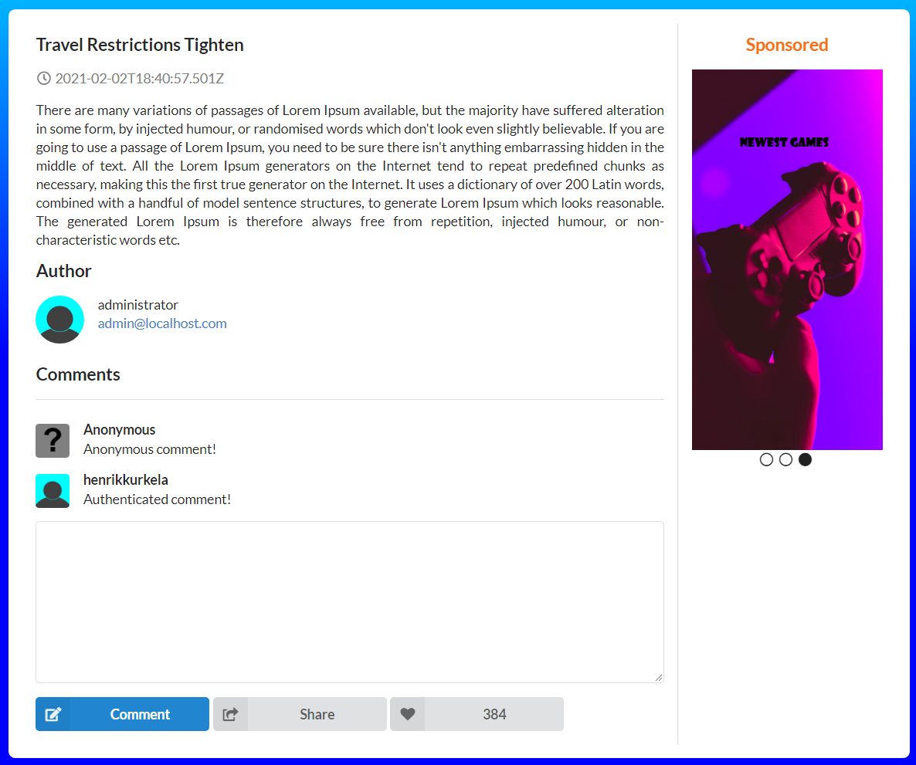

*Illustration of a typical news item view.*

## Liking and sharing

Liking and sharing are the bread and butter of any modern social media platform. News Site is no different in this regard and allows both anonymous and authenticated users to like and share news items to their hearts content. The grey like and share buttons are found on the bottom of a news item, right below the comment box.

## Commenting

To leave comments, simply click a news item on the site and scroll down to the comment section and start typing. A comment may be left anonymously, but anonymous comments may only be deleted by an administrator. Posting the typed comment may be done either by pressing enter, or by clicking the blue comment button right below the comment box.

Authenticated comments are comments left by users who have created an account on the News Site service and are currently logged in on said account. These comments differ from anonymous comments in two ways. The obvious difference is the fact that the username and avatar are displayed right next to the comment. The second difference is that authenticated comments may be deleted by the commenter if desired.

## Signing up and logging in

The log in button on the top right corner of the News Site platform leads to the login page. Below the credential inputs and login button is a link to the sign-up form. A valid email address and username consisting of 8 to 16 alphanumeric characters as well as a password must be provided. Clicking the sign-up button on the sign-up form will create a new user account with the desired credentials and redirect the browser back to the login form.

## Account management

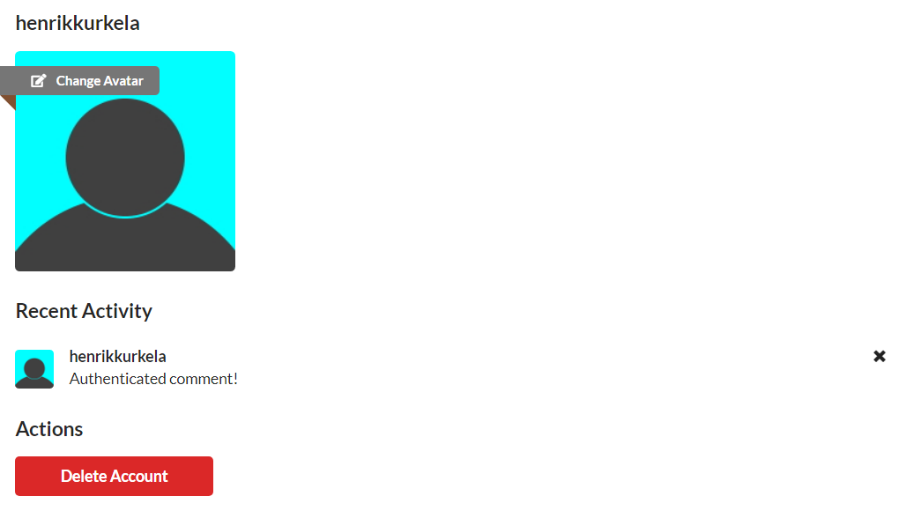

*Illustration of a typical user account management view*

While logged in authenticated users can review and manage their account by clicking a link labelled account at the top right corner of the page. Users may change their avatar by clicking their current avatar picture, review their comment history and delete their own comments, and if desired, unregister from the service completely by clicking the red delete account button.

# Content moderation

News Site platform has a comprehensive administration panel available to authenticated administrators. The tools may be accessed by clicking a link labelled moderation, only available to authenticated administrators, at the top right corner of the page. This chapter covers the basics of the most important moderation tools.

## Moderation actions overview

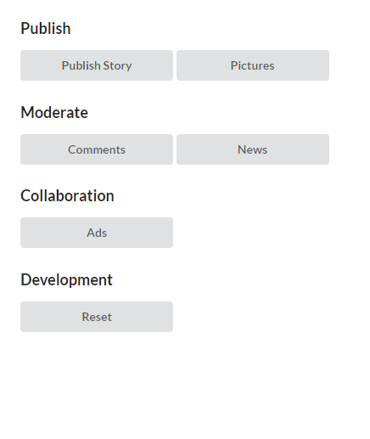

*Illustration of moderation panel available for authenticated administrators*

## Uploading picture assets

Picture assets may be uploaded by clicking the pictures button on the moderation panel. This will make an upload box available. The pictures view also displays all current picture assets available. Unneeded picture assets may be deleted by clicking them and selecting the delete option. Notice that some picture assets belong to the default configuration of the News Site platform and may not be deleted.

## Publishing news items

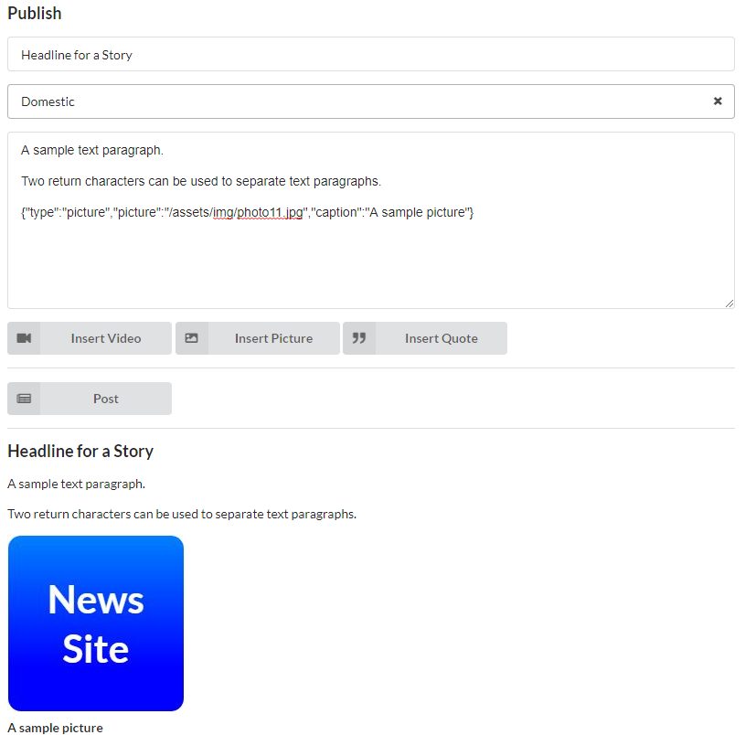

*Illustration of the publisher view*

New news items are created using the publisher view. The view is accessible from moderation panel by clicking the publish story button. Pictures, YouTube videos and pull quotes may be added to a news item by clicking the corresponding buttons right below the content field. Adding a picture, YouTube video or pull quote will append the content field with the corresponding JSON string, and the news item preview will display the added media. Only pictures previously uploaded may be utilised. Clicking the post button will publish the news item and redirect the browser to the newly created news item.

## Comment moderation

Unlike normal user accounts, administrators can delete any comments from all users. Comment moderation is accessed through the moderation panel by clicking the comments button. A list of all comments on all news items is displayed. Every comment has a black cross on the top right corner, allowing the deletion of said comment.

## News moderation

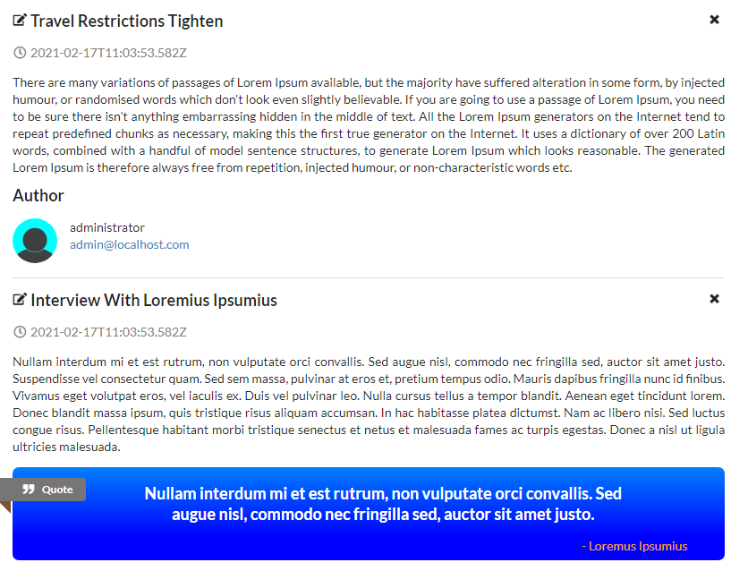

*Illustration of the news moderation view*

Updating or deleting a previously published news items is possible through the moderation panel by clicking the news button. A list of all news items is displayed. Every news item has a black cross on the top right corner, allowing the deletion of said news item. Every news item has an edit icon on the top left corner, allowing the amendment of said news item. Clicking the edit icon will open the news item in the publisher view with all the fields already populated. The item may be edited as necessary, and the changes may be saved using the save button.

## Advertisements

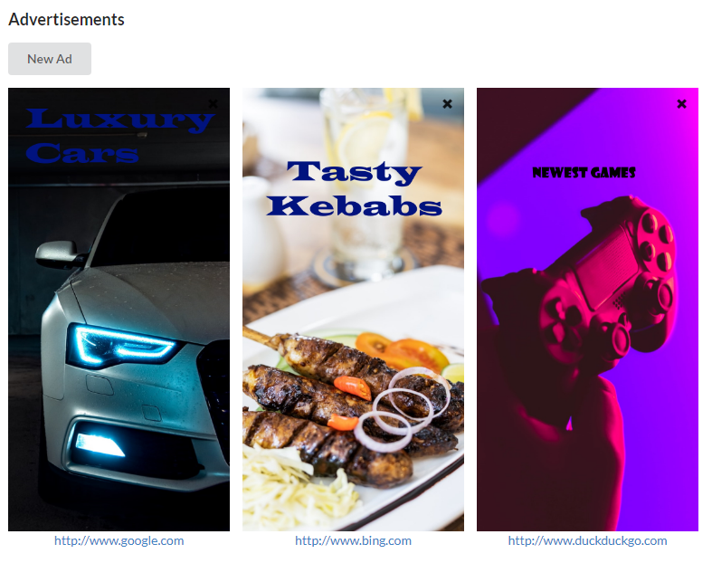

*Illustration of the advertisement manager view*

Advertisements are managed through the moderation panel. Clicking the ads button opens the News Site advertisement manager view, which displays all current advertisements. Every current advertisement has a black cross on the top right corner of the advertisement. Clicking the black cross will allow a moderator to remove the corresponding advertisement from the site.

New advertisements may be added by clicking the new ad button on the top of the advertisement view. This will open a modal with a picture selection area and a caption text input. A previously uploaded 750 by 1500 picture should be utilised for the advertisement picture. The desired address for the advertisement should be typed to the caption box. Clicking insert will create the new advertisement and include it in the advertisement carousel, visible on desktop and tablet devices. Currently, advertisements are not displayed on the mobile version of the site.

## Reset

The News Site platform may be reset to default story and account configuration by clicking the reset button on the moderation panel. This will permanently remove all user accounts, comments and news items and replace them with the default configuration presented in the source code.